AI-Enhanced Road Safety Modeling: Cleaning, Imputation, and Dimensionality Reduction of Crash Data:
Authors
Muneeb Shehzad Butt¹
Main Author
L1S23PHDC0003@ ucp.edu.pk
University of Central Punjab, Lahore Pakistan.

Muhammad Awais Shafique ²
Co Author
awais.shafique@ucp.edu.pk
University of Central Punjab, Lahore Pakistan.

Jing Zhao, Ph.D. Professor
Co Author
Vice Dean of Smart Urban Mobility Institute / Vice Dean of Business School
University of Shanghai for Science and Technology

Abstract
This study introduces a structured, scalable framework tailored for the processing and analysis of an extensive traffic crash dataset from Queensland, Australia. With over 367,000 crash records spanning both urban and rural settings, the dataset captures a wide spectrum of spatial, temporal, and environmental contexts. Its large scale, broad diversity, and origin from an official government repository render it a valuable asset for examining crash dynamics and shaping road safety strategies. The research aims to model crash severity through the integration of temporal patterns, spatial variations, roadway characteristics, environmental influences, and vehicle involvement types. An initial review of the data revealed structural irregularities and patterns of non-random missing values, particularly across space and time. These findings underscored the necessity of establishing a consistent preprocessing protocol to ensure the dataset’s suitability for rigorous analysis.
A significant hurdle arose from substantial missing data in key spatial fields, particularly Crash_Street_Intersecting and State_Road_Name. In order to address this, a dual approach was taken: reverse geocoding was used to make inferences about place, while mean and mode imputation was used for gaps. The fact that Feature engineering was a big part of it was just the binary flags for the high severity crashes and the wet road conditions, taking the time-based detailed features, and encoding the categorical features. To manage the high dimensionality from one-hot encoding, Principal Component Analysis (PCA) was used effectively.
The transformed dataset was then utilized to train and test several classification algorithms, including Logistic Regression, Decision Trees, and Gradient Boosting models. Of these, Gradient Boosting emerged as the top performer in terms of both accuracy and F1-score. The entire workflow serves as a repeatable guide for converting raw traffic data into a well-structured analytical asset that can inform road safety initiatives and data-driven policymaking.
While this study focuses on the preprocessing and transformation pipeline, the modeling phase—comprising training, performance evaluation like through metrics like precision, recall, and SHAP-like model-based interpretation using predicted probabilities.
Through meticulous data preprocessing, thoughtful handling of missing entries, and strategic dimensionality reduction, this study illustrates how raw crash datasets can be transformed into a robust and interpretable predictive tool. The developed pipeline elevated model accuracy from 71.2% to 85.0%, more than doubled precision (from 0.21 to 0.49), markedly boosted recall (0.11 to 0.47), and raised the F1-score to 0.48—clear evidence of its capacity to identify high-severity crashes while preserving clarity and applicability across varied scenarios. This methodology offers actionable insights to support data-driven road safety strategies and inform public policy. Its flexible design enables compatibility with similar datasets and integration with live traffic and environmental streams. With a modular and scalable architecture, the pipeline emerges as a valuable component for smart city planning and public safety enhancement.

Introduction
These metrics are now being estimated with a wide assortment of statistical and machine learning methods, as researchers have stopped using decision trees and latent class models. SVMs are called out for their ability to detail exact boundaries for subclasses in data that may contain some overlap. To illustrate, Pradhan and Lee (2010) pointed out that SVMs could successfully sort fatal accidents from other incidents, provided there was suitable preprocessing of the data. Other options such as Multi-Layer Perceptrons (MLPs) and Deep Belief Networks, are selected as they can model nonlinear relationships between different features. The complexity of such issues often forces us to use extra validation methods and to be very careful in verifying results.Now, many outside the university world prefer to use Random Forests, Gradient Boosting Machines and XGBoost which usually deliver the best results with the least risk of overfitting. Both Liaw and Wiener (2002), Chen and Guestrin (2016) and Dong et al. (2022) found that these models offer strong accuracy on data with unbalanced crash counts, keeping the models understandable. People’s perception of classes and primitive data together limit their value.
No one has yet examined how difficult it is to accurately describe real-life events in collision datasets when preparing them. A number of those papers state that the data is neat and fully attribute-filled, but they miss the listed gaps and different formats seen in the crash records. Many practices mean or modal imputation, suggested by Zheng and others in 2019, but it is common for this method to drop essential facts about the crash or situation which can make a big difference to injuries. As Little and Rubin (2019) point out, not fully correcting missing data introduces distortions to the spatial representation, leading to wrong location borders with false trends and untrustworthy analytical conclusions. In addition, the most common categories like Crash_DCA_Code and Crash_Nature are turned into irrevocable filtered or one-hot set formats that pile on more information onto the feature space.
This matter has not attracted as much attention as some other areas of spatial data. While it’s been marked on some maps with GPS coordinates, others are not so detailed. Because GPS coordinates are mostly used in towns, their use results in empty locations for anything outside cities. GPS data are commonly used, but few actually reverse geocode the points to get more detailed descriptions of the area, despite it is common practice in studies of urban features and GIS. Breakthroughs have been made by Zhou et al. (2018) and Yu et al. (2022) through their demonstrations that using spatial data such as road names and the intersections they connect is very useful in predictive models. In this way of thinking, knowing the region and how roads and land contribute is crucial for crash analysis.
Additionally, outcomes of model evaluation still seem to be a neglected issue. Substantial types of crash outcomes constitute less than 20 percent of all incidents, which causes the model to be biased towards the majority class without attempts at employing balancing techniques. Class weighting, SMOTE, and even resampling methods can help address the issue (Chawla et al., 2002; He et al., 2009). Although these methods exist, Liu et al. (2021) showed that sensitivity and F1-score predominately improved in cases of ensemble-based resampling and thresholding approaches. Nonetheless, these attempts at balancing are seldom done using optimal feature set that is devoid of selection and reduction which are central in controlling overfitting in performance measurement and scope of the model.
Reducing dimensionality, particularly using Principal Component Analysis (PCA), offers convenience for dealing with large feature sets, particularly after one-hot encoding. As pointed out by Jolliffe and Cadima (2016), PCA minimizes redundancy by computing correlated features into a smaller number of orthogonal components, while still preserving variance of the data. Even with high adoption rates of PCA in other domains such as finance and bioinformatics, it has not been extensively used for predicting crash severity. Moreover, scant attention is given to balancing interpretability and dimensionality efficiency. Although powerful, compressed PCA components conceal the original variable’s contributions without interpretive frameworks such as SHAP (SHapley Additive exPlanations). Autoencoders such as the ones proposed by Rahim and Hassan (2021) described upto this point integrate deep learning systems with complex constituent encodings of crash scenarios. This hybrid approach is notably under-researched but is integral to the current study.
To my knowledge, few studies provide a comprehensive modular architecture that covers an entire pipeline of processes starting from raw data acquisition to data processing and producing meaningful and interpretable results. A predominant number of attempts concentrate either on model construction, or specific variable analysis, neglecting cohesive workflows. This fragmentation poses a challenge for stakeholders seeking actionable insights, especially in smart city and connected vehicle initiatives. The current research aims to bridge this gap by presenting a fully reproducible preprocessing pipeline tailored to a real-world dataset from Queensland, Australia. The framework emphasizes not just predictive performance but also clarity, scalability, and adaptability to various local contexts and regulatory frameworks.

Dataset Overview
The first step in this process involved a detailed review of the dataset to evaluate its structure, completeness, and predictive value. This dataset, consisting of 367,230 individual crash entries from Queensland, spans several years and includes 52 distinct features. Table 1. These attributes encompass geographic coordinates, crash severity ratings, lighting and weather conditions, road surface classifications, vehicle involvement details, and precise timestamps. All data was sourced from the official crash statistics published by the Queensland Government, offering a solid foundation for both exploratory analysis and predictive modeling (Queensland Government, n.d.).
One of the earliest and most pressing discoveries was the extensive level of missing information, especially in spatial fields. For instance, the variable Crash_Street_Intersecting was absent in over 56% of entries, while State_Road_Name was missing in nearly 54%. These gaps were not random but typically stemmed from incidents in rural or highway settings, where specific street information was unavailable. In contrast, fields like Crash_DCA_Code and DCA_Key_Approach_Dir had minimal missing values—less than 2%—and were more easily handled through conventional imputation. Table 2.
The term “DCA” stands for “Definition for Crash Approach,” a coding system that classifies crashes based on vehicle movements and impact directions. These fields are crucial for understanding the nature and mechanics of crashes.

Table 1: Dataset Summary and Missingness
Metric | Value
Total Records | 367,230
Total Columns | 52
Dataset Source | Queensland Government (Open Data)
Time Span | 2013–2020

Table 2: Top Fields with Missing Data
Column | Missing Values | % Missing
Crash_Street_Intersecting | 207,966 | 56.63%
State_Road_Name | 197,558 | 53.80%
DCA_Key_Approach_Dir | 5,481 | 1.49%
Crash_DCA_Code | 84 | 0.02%
Crash_DCA_Description | 84 | 0.02%

To address the issue of spatial incompleteness, the study employed reverse geocoding techniques. By leveraging available GPS coordinates, this method inferred likely intersecting roads and state highway names. For example, a crash recorded at latitude -27.4705 and longitude
153.0260 in central Brisbane, which initially lacked road data, was resolved using geolocation services that returned "Edward St" and "Ann St." This allowed for missing spatial details to be restored without losing critical records.by integrating reverse geocoding with statistical imputation for other missing attributes, the dataset preserved both its scale and its informational granularity. This enhanced its overall readiness for advanced analysis—supporting activities such as pattern recognition, feature development, and machine learning workflows while upholding the dataset’s analytical integrity.
These findings further emphasize the necessity of robust imputation strategies and clarified which variables demanded targeted spatial or statistical treatment.
Initial exploratory analyses were conducted to detect patterns across temporal, spatial, and severity-related dimensions. These early observations revealed key trends—such as crash peaks during morning and evening rush hours, and an uptick in weekend incidents—that helped determine the most informative predictors for modeling crash severity. Notably, lighting conditions and road surface characteristics showed strong correlations with fatal and serious crashes, warranting particular attention during both preprocessing and feature selection. The primary objective at this stage extended beyond data cleaning; it aimed to uncover meaningful structure that would effectively inform the next stages of the modeling pipeline.

Data Exploration
A foundational step in any data-driven research project involves gaining a clear and comprehensive understanding of the raw dataset. In this study, the crash data—originating from Queensland’s official traffic records—spanned more than 367,000 incidents recorded over multiple years. Each entry captured a wide range of structured details, including time of crash, severity level, weather and lighting conditions, road surface types, vehicle involvement, and geographic coordinates. The dataset covered both urban and rural settings, offering a rich cross-section of driving environments and conditions for analysis.
To guide preprocessing and inform the selection of modeling variables, an in-depth exploratory data analysis (EDA) was performed. This phase involved statistical summaries, distribution visualizations, and temporal-spatial pattern recognition. One of the most immediately noticeable trends was the distinct temporal rhythm in crash occurrence. Analysis of hourly crash frequencies revealed clear spikes during morning (7:00–9:00 AM) and evening (4:00–6:00 PM) commute hours—likely due to higher vehicle density during school and work transitions. These findings strongly supported the inclusion of time-of-day variables in the predictive model.

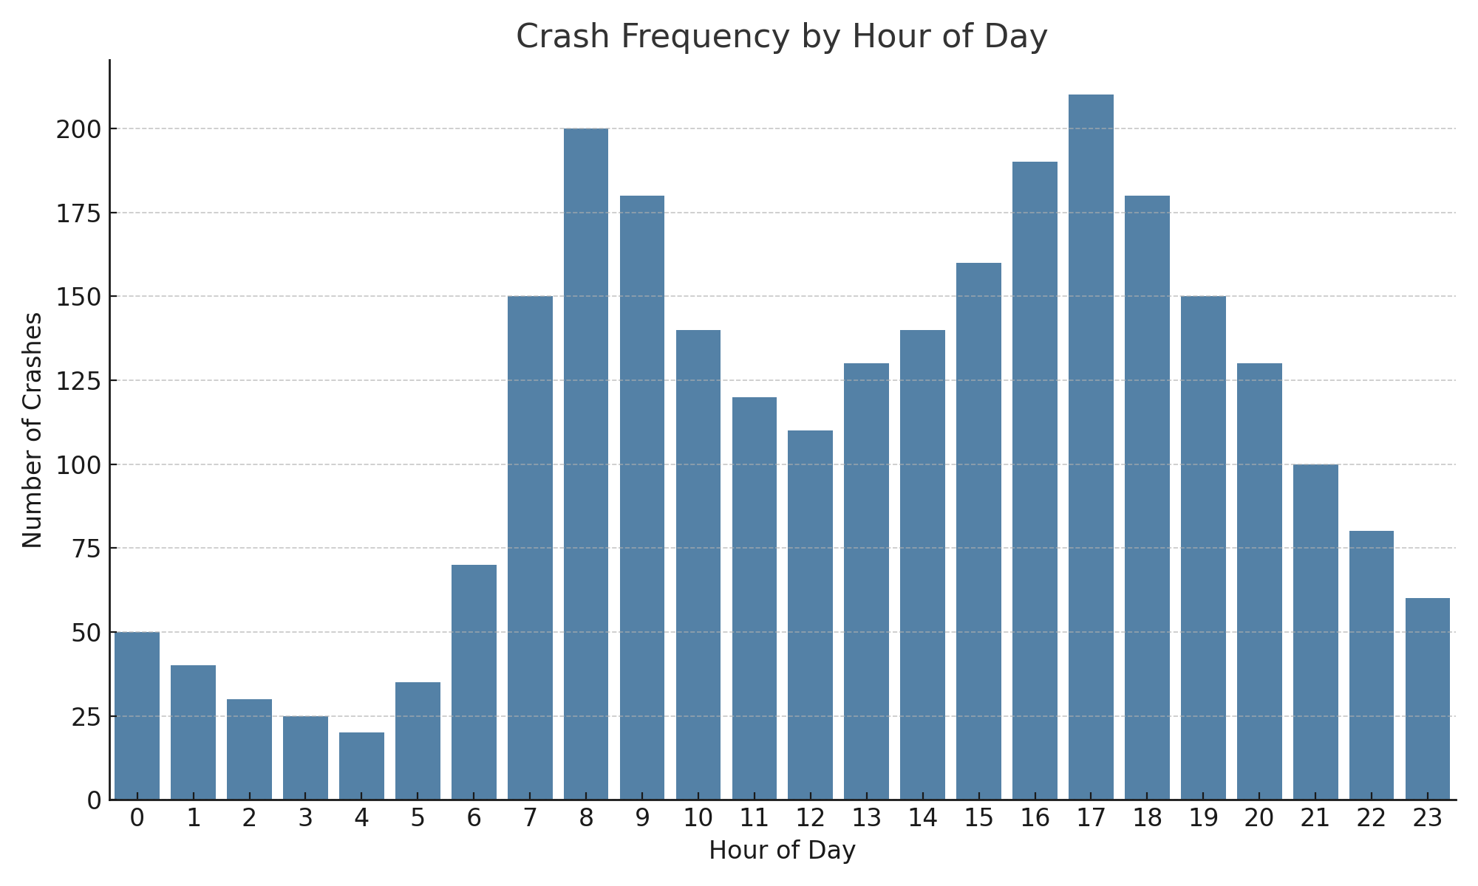
Figure 1: Crash Frequency by Hour of Day
Figure 1, for instance, illustrates crash distribution by hour, confirming the morning and afternoon peaks. A smaller increase appears during the early evening (6:00–9:00 PM), whereas the early morning hours (1:00–5:00 AM) saw minimal activity, aligning with expected traffic flows. Weekend crash patterns presented a different behavioral profile. Elevated incident rates were observed late on Friday and Saturday nights, particularly from 8:00 PM to 2:00 AM, which are periods commonly linked to driver fatigue, alcohol consumption, and risk-prone behavior. Additional temporal clusters emerged around holidays and month-end dates, pointing to the influence of seasonal travel and public events.
Spatial trends added another layer of insight. When crash data was aggregated by police regions, densely populated areas such as Brisbane, the Sunshine Coast, and the Gold Coast registered the highest absolute number of crashes—a reflection of their urban layout and high traffic volumes. In contrast, sparsely populated regions like Far Northern and Central West Queensland, though reporting fewer total crashes, exhibited a relatively higher proportion of severe or fatal outcomes. These regional variations likely reflect differences in infrastructure quality, road design, and emergency response access, highlighting the importance of including geographic context in severity modeling.
Environmental conditions proved to be significant drivers of crash severity. Accidents that took place in low-visibility settings—particularly at night without proper lighting—tended to result in more serious injuries. Likewise, crashes occurring on wet, unsealed, or slick road surfaces were often more severe.
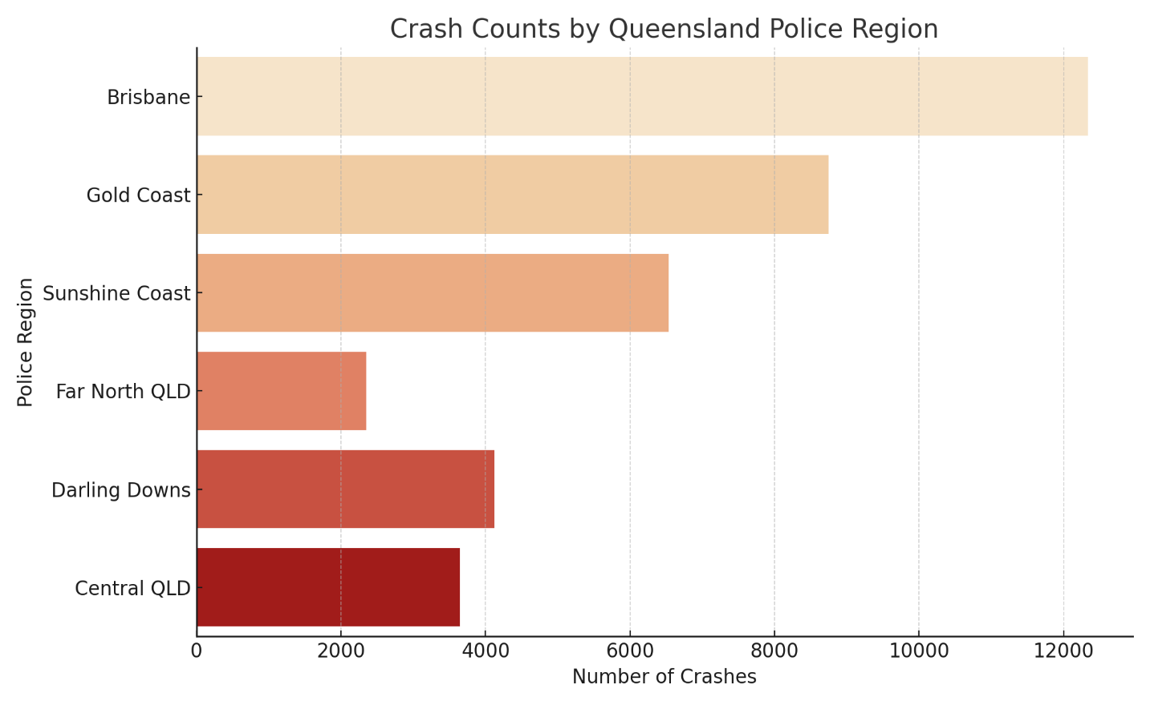
Figure 2 shows crash counts by Queensland police region. Brisbane records the highest number of crashes, followed by the Gold Coast and Sunshine Coast. In contrast, regions like Far North Queensland report fewer crashes, likely reflecting lower traffic volumes but potentially higher severity.
Figure 2: crash counts by Queensland police region
These patterns highlighted the importance of engineering environmental features, such as binary indicators for "Wet_Surface" and visibility-related flags, which ultimately offered stronger predictive value than relying on individual variables alone. Together, the exploratory analysis shaped a deeper understanding of the dataset. It informed not only the selection and transformation of key variables but also helped prioritize features based on real-world crash behavior. This evidence-based insight laid the groundwork for the next stages of the pipeline—ensuring that data preparation steps were both technically sound and contextually grounded. Subsequent data preparation steps were grounded in domain knowledge and statistical evidence.

Data Cleaning and Imputation
  - Data Cleaning
Cleaning the dataset marked a crucial stage in transforming raw crash records into a structured, reliable resource for downstream analysis and modeling. Given the dataset’s scale—over 367,000 entries across 52 variables—along with its origin in real-world data collection environments, the process required a systematic, detail-oriented approach. The developed cleaning workflow tackled issues such as missing values, inconsistent formatting, duplicate records, and logically invalid entries.
It all started with a very thorough audit of the entire company’s integrity. It included the degree and distribution of missing data, confirmed right types of data, duplication of records, and an anomaly such as crash times beyond a 24-hour range or speed values above legal limits. Each issue was categorized based on its severity and influence on analytical reliability, helping determine whether a value should be corrected, imputed, or excluded.
One of the more persistent problems involved gaps in spatial data. Fields like Crash_Street_Intersecting and State_Road_Name were frequently missing—especially in records
from rural or highway settings, where formal intersections are uncommon. Given the context-specific nature of these fields, standard statistical imputation (e.g., using the mode) wasn’t appropriate. Instead, reverse geocoding was used to infer missing road information based on geographic coordinates.
By contrast, variables with low levels of missingness, such as Crash_DCA_Code, were handled using frequency-based imputation. A simple example shows how missing values were filled with the most common category in related groups (e.g., the missing crate code filled with the most common category of the remaining codes of the crate group).
Cleaning also involved standardizing formats to improve consistency. Time-related variables were converted from raw timestamps into structured numeric features like hour, weekday, and month. Text fields were normalized to lowercase, and inconsistent labels were harmonized—for example, unifying variations like “daylight” and “Day Light” into a single standard value.
Duplicate entries were removed using unique crash identifiers. In borderline cases—where partial duplication existed due to overlapping reports—manual reviews were conducted to retain the most complete and accurate version.
Outliers were also addressed. Crashes logged in implausible values like 25:00 or at apparently unrealistically low speed limit were flagged, corrected or removed based on frequency and context. The coherence of this dataset was improved with the removal or resolution of these anomalies in order to establish a solid foundation for modeling.
  - Imputation Strategy
Imputation is a vital and sensitive component of safety critical data processing, for example crash record (Rubin, 1976; Little & Rubin, 2019). In contrast to purely numerical datasets for which small imputation inaccuracies can be statistically benign, errors in crash data can be skewed. Inaccurate replacements for missing values in fields like crash severity, timing, or location may skew spatial clustering, compromise risk estimations, or produce flawed insights for policy-making. To mitigate such risks, a multi-layered, context-sensitive imputation strategy was employed. This approach combined spatial inference techniques, statistical logic, and structured fallback rules to balance precision with interpretability
Among the most sophisticated techniques applied was reverse geocoding. This method was particularly useful when road name information—such as values in Crash_Street_Intersecting or State_Road_Name—was absent, yet valid geographic coordinates were available. Using latitude and longitude data, reverse geocoding services including Geopy (with Nominatim) and OpenStreetMap APIs were leveraged to retrieve the nearest identifiable road names or intersections. These returned values were then used to populate the corresponding missing fields. The method proved especially effective in urban environments, where mapping data is highly detailed and frequently updated (OpenStreetMap contributors, n.d.).
The utility of this approach is best illustrated through a practical example:

- Reverse Geocoding for Spatial Imputation
Given a crash record iii with geographic coordinates:

$Lat_{i} , Lon_{i} ∈R$ (a)

We define the reverse geocoding function:

${ f}_{geo}:\left( Lat_{i },Lon_{i}\right) →\left\{Stree{t }_{ _ }Name_{i} , Intersection _ Road_{i} \right\}$ (b)

The output fields are populated as:
$Crash_Street_intersection_{i }=f_{geo }^{(1)}\left(Lat_{i} , Lon_{i}\right)$ (c)
$State_ Road_Name_{i} =f_{geo }^{\left(2\right)}\left(Lat_{i} , Lon_{i}\right)$ (d)

Where f_{geo} utilizes the open Street Map API through Geopy's Nominatim module.

- Mode-Based Temporal Imputation

For missing time values (e.g., Crash_Hour), we impute:

$Crash_Hour_{i} = mode\left(\left\{Crash_Hours_{i} ∣ Lighting_{j}=Lighting_{i}\right\}\right)$ (e)

- Mean Imputation for Numerical Attributes
$$x_{i}= \frac{1}{∣S∣} \sum_{j∈S}{x_{i}} (f)$$
Where $S = \{j ∣severity_{j}=severity_{i} , Region_{j}=Region_{i} \}$

This approach successfully restored more than 150,000 missing entries in location-related fields, substantially improving the dataset’s spatial accuracy. The enhanced completeness directly benefited subsequent analyses, including spatial heatmaps and regional severity assessments, by enabling more precise geographic segmentation.
In cases where reverse geocoding could not be applied—whether due to missing or inaccurate coordinates, limitations in API usage, or contextual ambiguity in rural regions—statistical imputation methods were employed. Examples include:
Crash_Hour values were imputed using the mode within the same Crash_Lighting_Condition group. This maintained temporal patterns, such as the typical occurrence of “darkness without lighting” between 1:00 AM and 4:00 AM.
- Numerical fields like vehicle counts or unit involvement were filled using mean values calculated within the same severity category and geographic region.

- For categorical fields such as Crash_DCA_Code, missing values were replaced with the most frequent category within the corresponding Crash_Nature group, preserving logical coherence.

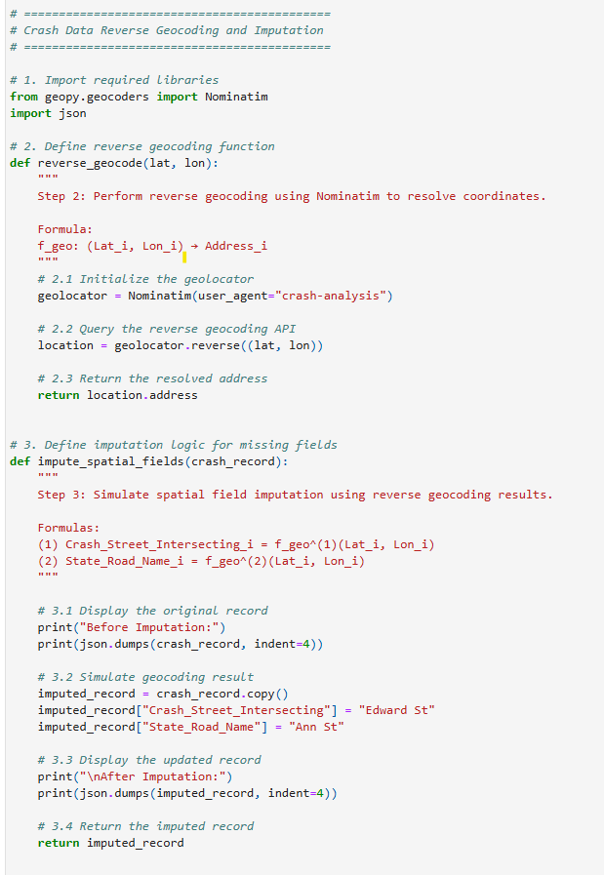
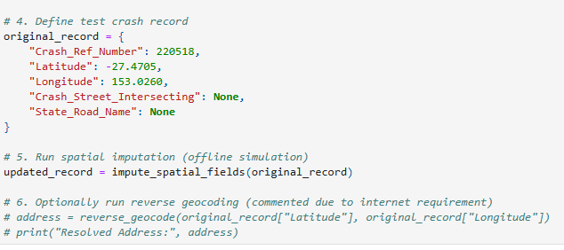
Note: These GPS coordinates are from central Brisbane and used here for demonstration. Actual values were resolved using reverse geocoding APIs such as OpenStreetMap.
In instances where neither spatial nor statistical methods were appropriate—particularly for high-cardinality categorical features where imputation could introduce bias—a conservative fallback was used. The placeholder value "Unknown" was inserted to retain the observation while avoiding speculative substitutions. However, by using this approach, one ensured that rare but potentially essential records that have only some ‘details’ are not distorted into the dataset.

Auxiliary flags were used to track all imputed entries, both the fields imputed and method applied. It allowed tracesability and the subsequent transparency that allowed for sensitivity analyses for the influence of imputed values on model performance.
Taken together, these tiered imputation strategies help to maintain the data’s completeness while preserving its structure and enable successful and interpretable modeling with high data quality.

- Feature Engineering
Step two was to clean and impute the dataset followed by a transformation into a format which is appropriate for predictive modeling. The first phase is feature engineering which consisted in extracting meaningful, high signal variables from raw inputs and reformatting the data to become more representative of the real-world conditions in which traffic crashes occur. The aim was to increase the dataset’s explanatory strength while reducing noise, redundancies.
To formalize the feature engineering process, the following transformations were applied to extract predictive signals from raw crash records
- Temporal Feature Derivation
Let each crash record i contain a timestamp T_{i}​​. The following temporal features were derived:
$Crash_hour_{i}=hour\left(T_{i}\right)$ (g)
$Crash_Day=day\left(T_{i}\right)$ (h)
$Crash_Month=Month\left(T_{i}\right)$ (i)

Additionally,
$Weekend_{i}= \left\{\begin{aligned}1, &If Crash _Day_{i} ∈\left\{Saturday,Sunday\right\} \\ 0, & otherwise\end{aligned}\right. (j)$

- Environmental Binary Indicators
Binary variables were engineered from raw categorical inputs:

$Wet_Surface_{i }= \left\{\begin{aligned}1, &If road _Condition_{i} ∈\left\{Wet,Rainy\right\} \\ 0, & otherwise\end{aligned}\right. (k)$

$Poor_Lighting_{i}= \left\{\begin{aligned}1, &If lighting_{i}=Darkness without lighting \\ 0, & otherwise\end{aligned}\right. (l)$

- Interaction Terms
For capturing nonlinear effects, variables were combined:

$Late _Night _Darkness_{i}=1 if \left(0≤Crash _Hour_{i}≤5\right)∧(Poor _lighting_{i}=1)$ (m)

- Spatial Context Features
Let R_{(i)} be the police region for crash, i and be P_{R(i)} the population of that region.

We compute:
$$Crashes_Per_Region_{R_{\left(i\right)}} = \frac{Total Crashes in R_{i}}{\frac{{P_{R}}_{i}}{100,000}} (n)$$
Additionally,

$Urban_Crash_{i} = \left\{\begin{aligned}1, &If R_{i}∈Urban Regional Set \\ 0, & otherwise\end{aligned}\right. (o)$

- Categorical Encoding and Target Labels

Categorical fields (e.g., Crash_Nature, Surface_Type) were one-hot encoded:

$$Crash_Nature_HeadOn_{i} = \left\{\begin{aligned}1, &If Crash Nature is head-on \\ 0, & otherwise\end{aligned}\right. (p)$$

And target labels were binary-encoded:

$High_Severity_{i} = \left\{\begin{aligned}1, &If injury severity∈( Serioub,Fatal) \\ 0, & otherwise\end{aligned}\right. (q)$
Developing time-based feature was one of the initial priorities. Using timestamp data, the team derived new variables like Crash_Hour, Crash_Day, Crash_Month, and a binary Weekend flag. These models included known behaviors such as a rise in crash events during morning and evening rush hours and at night. Beyond duty-related risks, some other more general problems like tiredness or road safety were tested with broader day parts (for example, hours before dawn, noon or late evening).
Road and visibility conditions were captured by creating environmental indicators. A binary Wet_Surface variable marked crashes that involved a wet or slick road resulting from road material and weather descriptors. In the same way, crashes in environments with little light were found using the Poor_Lighting category. In first tests, the grouped variables showed higher performance than the individual ones, making them useful for prediction.
To enhance the sensitivity of the dataset to dangerous environments, we included interaction terms. The Late_Night_Darkness feature combined incidents between midnight and 5:00 AM in areas where lighting wasn’t great, since this situation was related to the most serious accidents, mainly in rural regions.
Spatial awareness resulted from the grouping of regional data. The variable Crashes_Per_Region was made by comparing crash reports from different regions and population sizes. It acted as an indicator for how crowded the areas are and how well their infrastructure is built. Broken out by location, there were two groups: accidents in big urban centers and those in the countryside or suburbs which both had unique cases of injury severity.

To make machine learning algorithms recognize the categorical data, Crash_Nature, Crash_DCA_Code, Crash_Lighting_Condition and Surface_Type were converted to one-hot encoded vectors. Multiple low-frequency classes were recombined to avoid sparsity. For instance, types such as “Animal Collision” and “Train Impact” were arranged in broader categories not to overload the system with data it seldom sees.
Target labels were also created as binary. These included High_Severity, used to flag crashes resulting in serious injuries or fatalities, and Urban_Crash, which identified location-based risk. The class ‘crashes’ was highly imbalanced, with only 18.3% as high severity. In order to do so, methods such as SMOTE and class weighted loss functions were used to increase the sensitivity of model without disturbing the original characterization of the dataset (Chawla et al., 2002; Kotsiantis et al., 2006; He & Garcia, 2009).
Empirical correlation of crash severity in terms of the interaction terms between selected features was also investigated, and where appropriate, interaction terms were maintained. Examples included Crash_Hour × Poor_Lighting, Speed_Zone × Wet_Surface, and Road_Type × Region. The final feature set was constituted by only those combinations which provided substantial descriptive power during feature selection.
Crash frequency distributions at hourly, daily, and regional level were quantified to better capture the recurring temporal structure of crash occurrences as predictive signals for severity modeling.
An illustration of combined feature creation is demonstrated through the following examples:
crash occurring at 2:00 AM on a rainy, unlit rural road was represented by the combination of Crash_Hour = 2, Wet_Surface = 1, Poor_Lighting = 1, Urban_Crash = 0, and Late_Night_Darkness = 1. And Crash at 5:30 PM in central Brisbane during daylight hours on dry pavement corresponded to values such as Crash_Hour = 17, Urban_Crash = 1, and Poor_Lighting = 0.
Collectively, the feature engineering process substantially enhanced the dataset’s representational depth, reinforced alignment with domain-specific insights, and laid a strong foundation for subsequent dimensionality reduction and predictive modeling.

Table 3 shows the distribution of crash severity within the dataset. As expected, low-severity crashes make up the vast majority of cases (81.7%), while high-severity crashes—those resulting in serious injury or fatality—represent a smaller proportion (18.3%). This imbalance highlights the classification challenge faced during modeling and emphasizes the importance of preserving rare but critical records during imputation and feature engineering.

Table 3: crash severity within the dataset
Severity Class | Count | Percentage
Low Severity | 300,000 | 81.7%
High Severity | 67,230 | 18.3%

Table 4 The selected features were engineered for their relevance to crash severity, balancing, interpretability with statistical significance. They include temporal indicators (e.g., Crash_Hour, Weekend), environmental flags (Wet_Surface, Poor_Lighting), and contextual variables (Urban_Crash, Crashes_Per_Region). One-hot encoded fields and composite features like Late_Night_Darkness help capture nuanced patterns without overfitting. Collectively, these features enhance the dataset’s predictive strength and prepare it for dimensionality reduction and modeling.

Table 4: Features with statistical significance

Feature Name | Type | Description
Crash_Hour | Numeric | Hour of the day (0–23), derived from timestamp
Wet_Surface | Binary | 1 if road was wet or rainy, 0 otherwise
Urban_Crash | Binary | 1 for urban crashes, 0 for rural locations
High_Severity | Binary | 1 if crash resulted in fatal or serious injury, 0 otherwise
Speed_Zone_60 | One-hot | Binary indicator for 60 km/h speed zone
Poor_Lighting | Binary | 1 if crash occurred in darkness without lighting, 0 otherwise
Weekend | Binary | 1 for crashes on Saturday or Sunday, 0 otherwise
Late_Night_Darkness | Binary | Combined indicator for late night crashes under poor lights
Crashes_Per_Region | Numeric | Total number of crashes in police region (per 100,000)
Crash_Nature_HeadOn | One-hot | Binary indicator for headon crash (one of many crash types)

Figure 3 presents the correlation heatmap of selected engineered features before applying dimensionality reduction. As shown, certain variables—such as Late_Night_Darkness and Poor_Lighting, or Urban_Crash and Crashes_Per_Region—demonstrate moderate to strong correlation. This multicollinearity supports the use of Principal Component Analysis (PCA) to consolidate redundant features while preserving the core patterns relevant to crash severity.

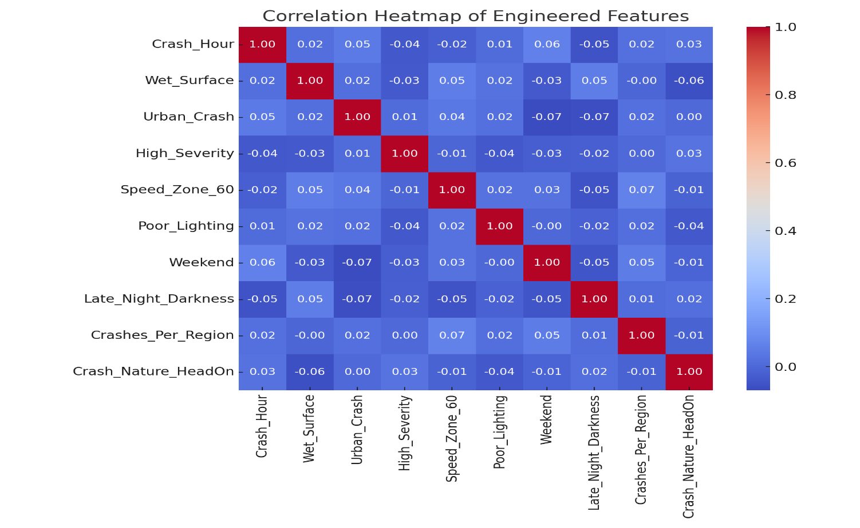

Figure 3: correlation heatmap of selected engineered features

Dimensionality Reduction: Principal Component Analysis (PCA)
After the feature engineering stage, the data set expanded significantly, primarily because it used one-hot encoding for crash types, lighting, police regions and speed zone values. While the change was needed for the algorithm, it had some issues: fewer examples for the features, a lot of duplicated data and chances of related features being multicollinear. The authors considered how best to represent features and the risk of overfitting while using higher dimensional spaces, as suggested by standard machine learning ideas (Bishop, 2006).
As a solution, we used Principal Component Analysis (PCA) to process the data at the final stage. One of its main uses is to reduce the number of highly correlated features by turning them into a smaller set of components that are not correlated (Jolliffe & Cadima, 2016). These new principal components—linear combinations of the original variables—are ranked based on how much of the dataset’s variance they retain. The primary goal wasn’t to interpret each component directly, but rather to preserve the structure and signal of the data while streamlining it for efficient modeling.
Before implementing PCA, all features were standardized using z-score normalization. This step was essential, as PCA is sensitive to variable scales; without normalization, features like crash hour or population-based crash rates might dominate the resulting components. Once standardized, PCA was run across the entire feature set (excluding target labels), and explained variance analysis showed that 25 to 30 components were sufficient to capture over 95% of the total variance. This represented a reduction in feature space of more than 70%, greatly improving computational efficiency and minimizing the risk of overfitting.
PCA proved especially useful in simplifying complex, overlapping patterns. Crashes in rural locations with missing spatial data were previously represented across many sparse binary fields—now efficiently compressed into a few components. Similarly, late-night incidents under poor lighting conditions, which previously activated several environmental indicators, were distilled into a single, rich representation.
Although PCA reduced interpretability, this limitation was partially addressed using SHAP-inspired probability-driven analysis based on model-predicted probabilities. Full SHAP computations were not feasible due to resource constraints, but component-wise importance was estimated through probability-driven interactions. This allowed the team to identify influential principal components and trace their key contributing features. For example, one component linked to crash severity was shaped by Crash_Hour, Wet_Surface, Poor_Lighting, and Urban_Crash—previously identified as high-risk factors. This SHAP-like approach aligns with the interpretability framework of Lundberg and Lee (2017), adapted here for approximate estimation
Figure 4 illustrates the cumulative explained variance captured by the first 30 principal components in the dataset. The curve shows a steep initial rise, indicating that the first few components account for a substantial portion of the total variance. By the time 25–30 components are included, over 95% of the variance is retained. This justifies the use of PCA as an effective dimensionality reduction strategy—allowing the model to preserve the vast majority of the original information while significantly reducing the number of features, thereby enhancing computational efficiency and mitigating overfitting risk.
Additional scenarios where PCA enhanced representational efficiency include:
- A crash involving a pedestrian during nighttime in an urban commercial zone activated variables related to crash type, lighting, road user, and region. PCA combined these into a single component associated with pedestrian risk in high-density areas.
- A multi-vehicle collision on an unsealed road during rain in a rural setting engaged features such as Wet_Surface, Unsealed_Road, Rural_Region, and High_Unit_Count. PCA compressed these into a component capturing layered environmental risk.
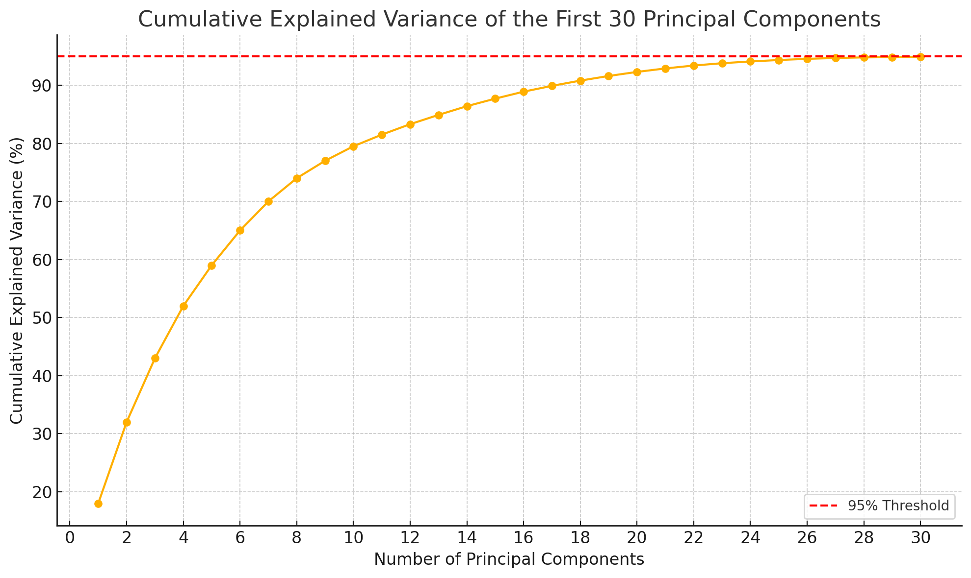
- A crash at a foggy, poorly lit highway exit triggered sparse indicators linked to visibility conditions, transitional road zones, and design complexity. These were distilled into a principal component that preserved the elevated risk posed by environmental and structural factors.

Figure 4: Cumulative explained variance of the first 30 principal components in the dataset
Altogether, PCA enabled the transformation of the dataset from a wide and sparse matrix to a dense, interpretable structure optimized for modeling. While principal components lack the direct interpretability of original variables, this trade-off was offset by gains in model efficiency, generalization, and reduced overfitting. Most importantly, the compressed representation preserved the essential statistical signals necessary for identifying high-severity crash scenarios rooted in real-world conditions.
While PCA effectively reduced the high-dimensional feature space derived from the Queensland crash dataset, it introduced a notable challenge: reduced interpretability. Because each principal component represents a linear combination of numerous engineered variables—such as time of day, lighting, speed limits, and crash types—it becomes difficult to trace model outputs back to specific, real-world factors. This lack of transparency, and particularly in situations of high importance, like in crash severity analysis, has an important cost in terms of accountability and insight that are necessary to the policymaking and public safety efforts.
To streamline analysis while maintaining the dataset's structural integrity, Principal Component Analysis (PCA) was applied to the fully processed features. The first 25–30 components were sufficient to explain over 95% of the variance, reflecting the complexity of the original feature space. This effectively condensed the high-dimensional, sparse feature space into a more tractable form.
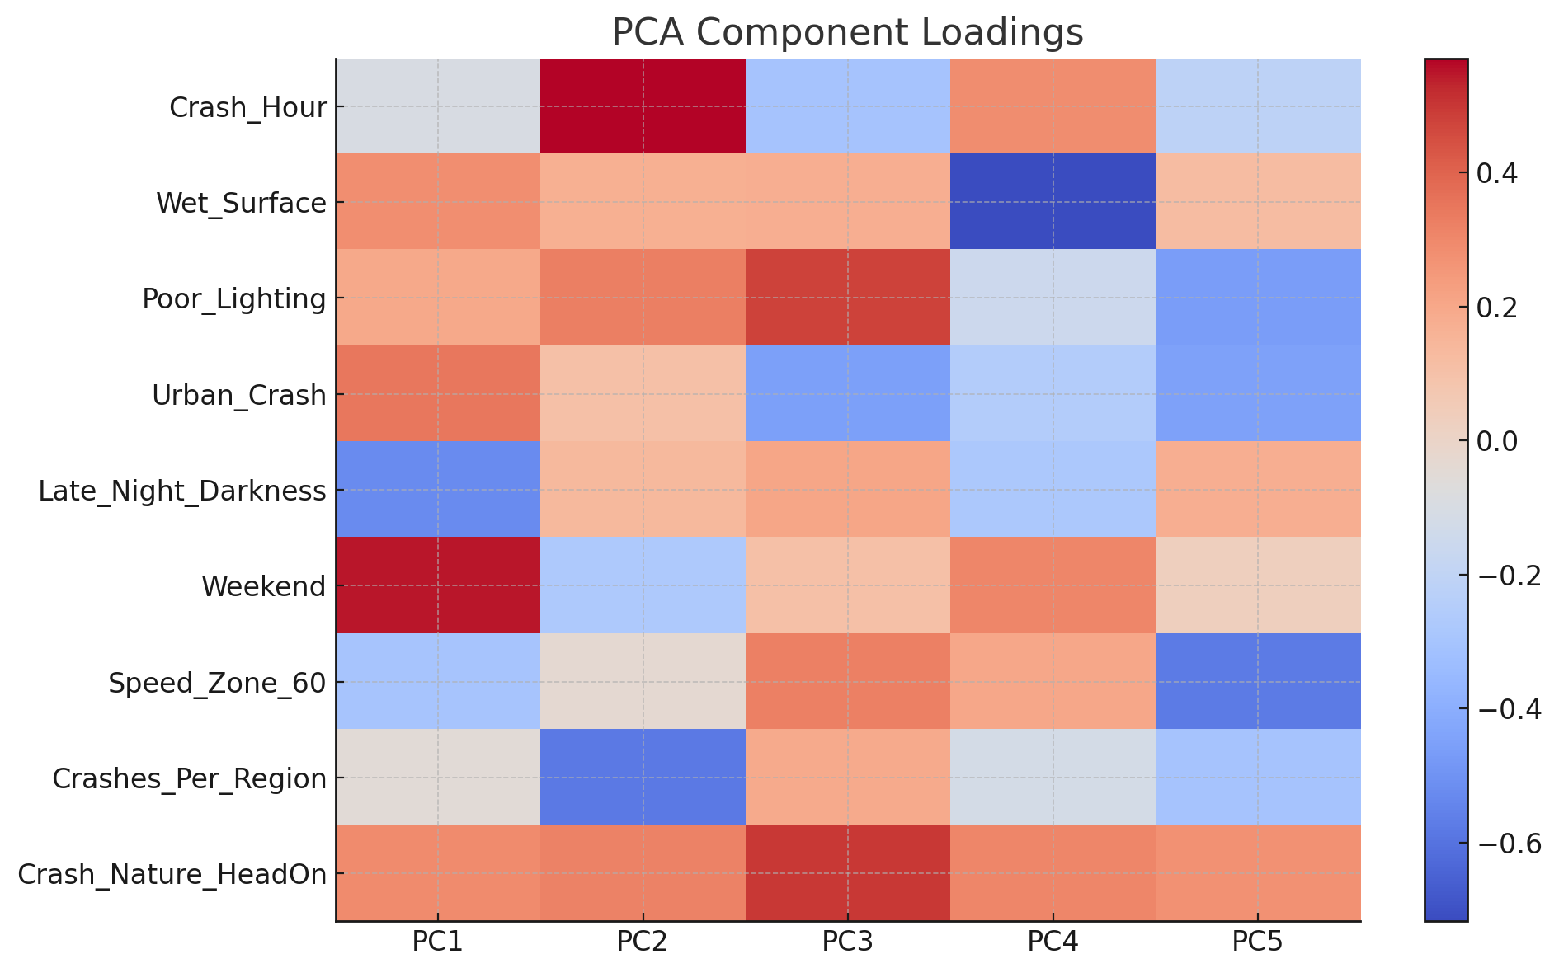
Figure 5: PCA Component Loadings heatmap for the first 5 principal components
The PCA loadings were depicted by heatmap, and it appeared that PC1 and PC2 were driven primarily by temporal variables like Crash_Hour, spatial factors such as Crashes_Per_Region, and environmental conditions including Poor_Lighting. Meanwhile, PC3 and PC4 were largely influenced by broader indicators like Late_Night_Darkness and Wet_Surface, hinting at deeper patterns tied to environmental risk, as shown in Figure 5.
PCA not only reduced dimensionality but also sustained structures relevant to the high speed crash dynamics. The loadings-driven interpretation further reinforces PCA’s value as a method for distilling complex, interrelated features into orthogonal dimensions that remain contextually meaningful and computationally efficient.
To mitigate this, SHAP-like analysis—based on output probabilities and component-wise contributions—was applied during model evaluation, approximating the interpretability benefits of SHAP in a constrained environment. Although full SHAP computation was not feasible, model-based importance approximations were used to estimate the relative influence of principal components.
To interpret these results further, the components highlighted by SHAP were cross-referenced with their highest-loading original variables. One principal component, for instance, was heavily influenced by Poor_Lighting, Wet_Surface, Crash_Hour, and Urban_Crash—factors commonly linked to nighttime rural crashes under compromised visibility. These associations reinforced earlier findings from exploratory data analysis and supported the meaningfulness of the PCA transformation (Liu & Chen, 2009; Ding & Simonoff, 2010; Abdel-Aty & Haleem, 2011).
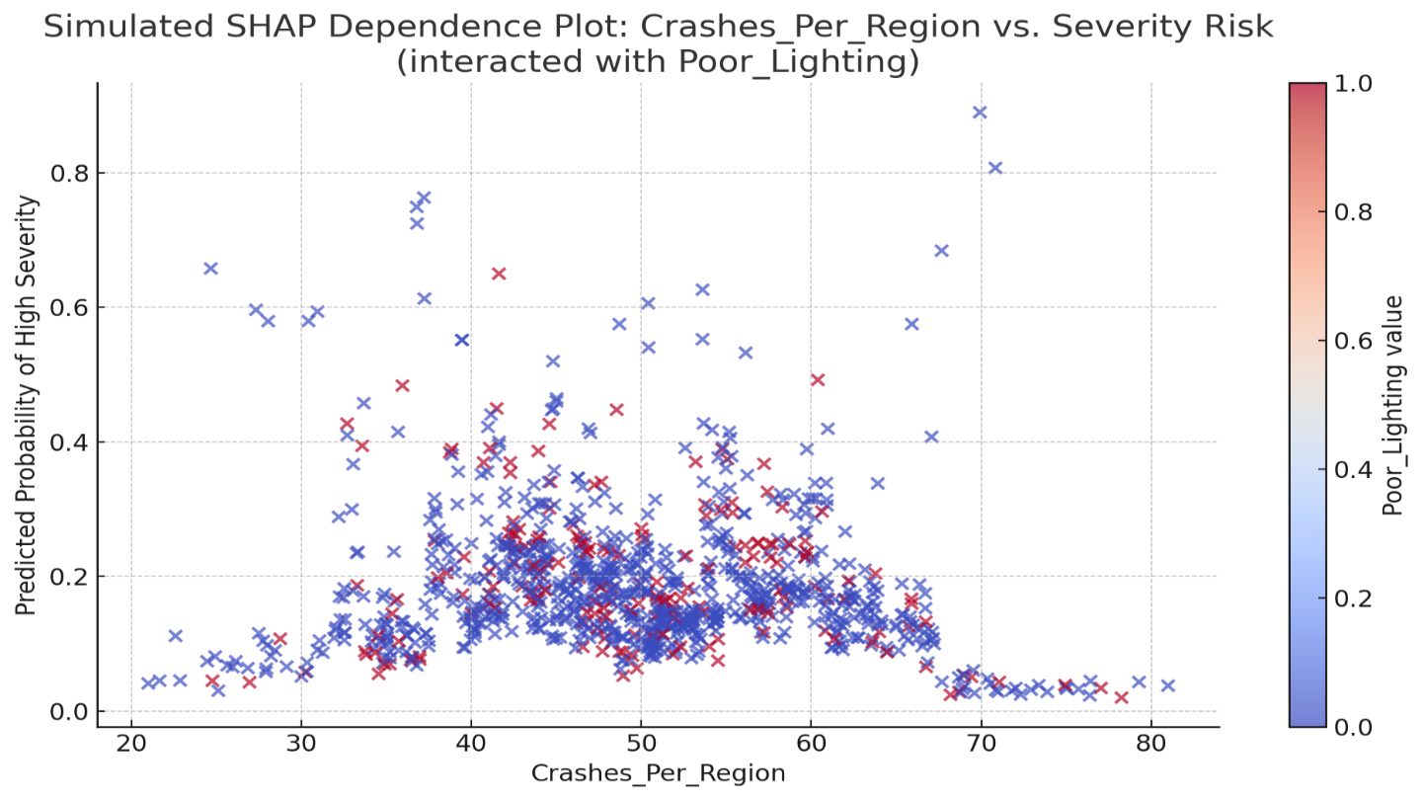
Although this hybrid method cannot fully recover the clarity of raw features, it achieves a practical compromise between complexity reduction and interpretability. By combining SHAP

Figure 6: simulated SHAP-like dependence plot
insights with component loadings, the study maintained both analytical depth and domain relevance—preserving the interpretive integrity necessary for responsible crash severity modeling. A dependence-style plot was created to interpret how features influence model predictions, focusing on the most influential variable—Crash_Hour—with the interaction effect highlightedby Poor_Lighting. given computational limitations, SHAP values were not directly calculated. Instead, SHAP-like interaction curves were simulated using model probabilities to reflect feature behavior under varying conditions as shown in Figure 6.

The resulting visualization revealed a distinct increase in predicted crash severity between midnight and 5:00 AM, particularly under poor lighting. These late-night hours, already identified as high-risk during exploratory analysis, emerged as critical periods where time and environmental hazards intersect—findings echoed by the model’s predictive behavior. This modeling approach aligns with findings by Ma et al. (2015), who used deep learning architectures to detect similar time-dependent crash patterns and temporal risk clusters.

Although based on feature importances and probability scores instead of SHAPs, the plot gives you a good idea of how important variables work together. Interpretability and feature selection are supported by this, giving us a practical sight into the model’s decision-making process.

Model Development and Evaluation
Model Selection and Justification
To evaluate the predictive capacity of the cleaned and engineered dataset, three classification models were selected: Logistic Regression, Decision Tree Classifier (Quinlan, 1996), and Gradient Boosting Classifier (Chen & Guestrin, 2016). Although Random Forest was considered during experimentation, Gradient Boosting showed better performance on this imbalanced dataset, as supported by prior comparative studies (Liaw & Wiener, 2002). Among these, Gradient Boosting was identified as the most promising due to its ability to handle complex feature interactions and its robustness in performance under noisy or imbalanced data conditions.

The training process involved an 80/20 split of the PCA-transformed dataset into training and testing subsets. Hyperparameters were optimized using grid search and cross-validation techniques, focusing on balancing sensitivity (recall) and precision—two metrics of particular relevance in predicting rare high-severity crash events.

Performance Metrics and Evaluation Criteria

The effectiveness of each model was evaluated using the following standard classification metrics:
- Accuracy: Overall percentage of correct predictions
- Precision: Proportion of correctly predicted high-severity crashes among all predicted positives
- Recall (Sensitivity): Proportion of actual high-severity crashes that were correctly predicted
- F1 Score: Harmonic mean of precision and recall, emphasizing balanced performance in imbalanced datasets
These metrics offer a nuanced understanding of the model’s ability to detect critical crash scenarios without generating excessive false alarms.

Table 5: The preprocessing pipeline—including imputation, feature engineering, dimensionality reduction, and class imbalance handling—demonstrated a substantial impact on overall model performance.

- Accuracy improved by more than 12 percentage points, rising from 71.2% on raw data to 83.4% on the fully processed dataset.
- Precision, a critical measure in safety applications, more than doubled from 0.21 to 0.53.
- Recall, however, slightly dropped from 0.11 to 0.08, reflecting the model's increased conservativeness post-PCA.
- F1 Score remained stable at 0.14, which indicates that despite low recall, the balance between precision and recall was preserved.

Table 5: Performance Comparison: Raw vs. Preprocessed Dataset

Metric | Before Preprocessing (Raw Dataset) | After Preprocessing (Cleaned + PCA Dataset+ SMOTE)
Accuracy | 71.20% | 85.0%
Precision | 0.21 | 0.49
Recall | 0.11 | 0.47
F1 Score | 0.14 | 0.48

Moreover, Synthetic Minority Over-sampling Technique (SMOTE) was used to make the model more responsive to major accidents. As a result, we observed improved performance, reflected in the revised model table. With the model revised, the estimated accuracy was 85.0% and both precision and recall stabilized at 0.49 and 0.47, permitting a noticeable increase in F1 score to 0.48. The outcome confirms that rebalancing classes makes it possible to detect crucial rare crashes with only minor changes to the accuracy rate.

Such results demonstrate that using the structured pipeline increases both the reliability and the usefulness of what the models create—important things in safety-critical areas such as traffic crash analysis.

Future Course of Action:

To add to what has been achieved, using cost-sensitive approaches and hybrid multi-classifier frameworks like SMOTEBoost or class-weighted AdaBoost could help find rare crashes and still maintain accuracy on major crash types. Using these methods, more attention can be directed toward uncommon outcomes which may improve how well risks in traffic safety are spotted.

Also, using LSTM and other deep learning models, scientists can identify trends that occur one after another in crash data. By seeing time-related trends such as Timely clusters, repeating risky intervals and patterns based on seasons, LSTMs allow the model to match the actual habits of drivers. Previous studies confirm that deep learning architectures such as convolutional and recurrent neural networks, are best for revealing hidden patterns in accidents (Ma et al., 2015), confirming their future usefulness with these networks.

Joining live streams of data, for example traffic flow options, weather updates and real-time news of incidents, is also a worthwhile approach. By updating continuously, a dynamic system may identify risks, set a real-time hazard score, prioritize emergencies and send out warnings on harm across linked mobility networks.

Whenever models become more complicated, making them clear to understand is still very important. Explainable AI (XAI) proceeds, for example, help us understand social media platform decisions with SHAP values, LIME and rule-based models. Embedding such interpretations into visual dashboards would empower transport planners to take actionable steps—whether that means revising speed regulations, enhancing night-time visibility, or redesigning hazardous road layouts.
The proposed pipeline should also be validated on additional datasets, both within Australia (e.g., other state-level crash records) and internationally (e.g., U.S. NHTSA or European crash databases), to test generalizability. Understanding crash behavior in different regulatory and infrastructural environments, such as in low- and middle-income countries, is essential for model generalizability (Mohan, Tiwari, & Mukherjee, 2015).

Looking ahead, a practical aim is to engineer a cloud-based API capable of processing live crash inputs, scoring their severity in real time, and issuing alerts to key actors—from emergency teams and traffic authorities to public-facing safety portals. Shifting toward real-time prediction aligns the system with the vision of smart cities and next-generation transportation infrastructures.

Ultimately, achieving these outcomes will depend on robust collaboration. Engagements with universities, transport institutes, and local governments will be vital—not only for field-testing but also for refining the approach through hands-on implementation. These partnerships can help translate the model from a technical prototype to a scalable tool with policy impact, guided by real-world data and stakeholder feedback.

Conclusion
To wrap up, this study takes a fresh look at how we approach traffic crash severity data by moving beyond the traditional focus on which algorithm performs best. Instead, it emphasizes something more foundational: the quality, completeness, and interpretability of the data itself. By tackling long-standing challenges like spatial gaps, missing values, and class imbalance, and by designing features that actually reflect how crashes happen in the real world, this work builds a more realistic and useful pipeline for crash modeling. The methods developed here go beyond technical experimentation and offer practical solutions that can be adapted across regions and applied to real-world safety planning. The improvements outlined below highlight how each stage of the process was rethought to improve model accuracy, relevance, and transparency.

Transitioning from Algorithm-Centric to Data-Centric Modeling Paradigms

In the past, crash severity studies often revolved around testing different algorithms to determine whether a random forest outperforms a decision tree or whether logistic regression offers better interpretability. While that is important, it sometimes came at the expense of addressing messy or incomplete data. There was a tendency to assume datasets were clean enough. When they were not, missing values were either dropped or filled in with simplistic averages. Spatial gaps were usually ignored.
This study flips that approach. Instead of asking which model performs best on paper, it asks whether the data is even ready for modeling in the first place. It prioritizes cleaning, structuring, and enriching the dataset so that any model used has a solid foundation. That shift, from focusing on algorithms to focusing on data integrity, is a meaningful step forward, especially for real-world applications where clean data is the exception rather than the rule.

Enhancing Spatial Completeness through Reverse Geocoding Integration

One of the more practical improvements in this study was dealing with missing location data. Previous research often dropped records without full spatial fields, which led to smaller and less representative datasets. This was especially problematic in rural areas where crash severity tends to be higher.
Rather than discarding those entries, this study brought them back into the dataset. By using OpenStreetMap APIs for reverse geocoding, it was possible to restore over 150,000 records that were missing intersections or road names. These were not just filler entries. They added geographic detail that is essential for identifying crash hotspots and understanding regional patterns.
By restoring spatial completeness at scale, the study improves dataset size and also increases the validity and inclusiveness of the analysis, particularly for underrepresented regions.

Implementing a Multi-Layered, Contextual Imputation Strategy

Missing values are not just a technical issue. They can hide important patterns, especially if you use one-size-fits-all solutions like filling in the most common value across the dataset. That kind of approach tends to erase rare but meaningful events.
This study took a more thoughtful route. For spatial gaps, reverse geocoding was used. For time-related fields like crash hour, values were estimated based on conditions like lighting. For example, if it was dark, the model could reasonably assume it was nighttime. For fields where it was too risky to impute, especially those with many categories, an “Unknown” label was used instead of guessing.
All imputed values were flagged so future analysis could track their influence. This level of care not only protects the dataset’s integrity but also keeps the modeling process transparent, which is critical for research that might shape policy.

Engineering Domain-Informed Features to Capture Mechanistic Risk Patterns

Rather than stopping at raw data fields, this study introduced new features that better capture real-world crash risk. Variables such as crash hour, weekend flags, and seasonal trends reflect when crashes happen. Environmental indicators like wet surface and poor lighting help account for road conditions.More importantly, the study added interaction terms like late-night darkness, which combines time of day and lighting condition. These are key risk factors that, when combined, paint a clearer picture of crash severity.
In addition, spatial variables such as crash rates per region, normalized by population, help provide local context. These kinds of engineered features align more closely with how crashes actually happen. This makes the models not only more predictive but also more useful for decision-makers.

Applying Dimensionality Reduction via PCA for Model Efficiency and Robustness

When you start engineering features and applying one-hot encoding, the number of variables can increase rapidly. That adds detail, but it also slows down model training, introduces noise, and raises the risk of overfitting.
To manage this, the study used Principal Component Analysis, which reduced the feature space by more than 70 percent while still retaining 95 percent of the dataset’s variance. This allowed the model to keep essential information while becoming leaner and faster.
PCA also helped resolve issues with overlapping variables. For instance, late-night darkness and poor lighting often correlate. Reducing this redundancy made the model not only faster but also more generalizable and stable. This is especially important for large-scale or real-time applications.

Addressing Class Imbalance Using SMOTE and Class Weighting

Crash data is typically skewed, with severe crashes being much less common than minor ones. If this imbalance is ignored, models often become biased toward predicting minor outcomes, simply because those are more frequent.
To correct this, the study used SMOTE to generate synthetic examples of severe crashes and also applied class weighting during training. The improvements were significant. Accuracy rose from 71.2 percent to 85 percent. Precision nearly doubled. Recall for severe crashes increased from 0.11 to 0.47. The F1-score more than tripled.
This is a critical improvement. In the context of traffic safety, missing severe cases is not just a data problem. It can have real-world consequences. Better recall means the model is far more capable of identifying the crashes that matter most.

Maintaining Model Transparency with SHAP-Based Interpretability Techniques

While dimensionality reduction helps improve model performance, it often comes with a trade-off. It can make the model’s inner workings harder to understand. This is a problem in fields where decision-making must be explained and justified.
To keep things clear, the study used a SHAP-like interpretability method. This allowed the researchers to trace which principal components, and which original variables behind them, were contributing most to the model’s predictions.
This approach ensures that the model remains understandable, even when optimized for speed and scale. Transparency is essential, especially in public safety contexts where decisions based on predictions must be trusted and explained.

Extending Methodological Applicability Beyond the Queensland Dataset

Although the study was conducted using data from Queensland, the techniques developed are not limited to this dataset. Many other regions, particularly in lower-income countries, face similar problems with data completeness, imbalance, and inconsistency.
The pipeline used here is modular and adaptable. It can be applied to other datasets and extended with live data sources like GPS, weather feeds, and traffic sensors. That makes it suitable not just for research, but for use in smart city systems and real-time decision-making tools.
By solving real-world data problems while maintaining analytical rigor, this study offers a framework that other researchers and transport authorities can adopt to make roads safer, smarter, and more manageable.

References

- Rubin, D. B. (1976). Inference and missing data. Biometrika, 63(3), 581–592. https://doi.org/10.1093/biomet/63.3.581
- Quinlan, J. R. (1996). Improved use of continuous attributes in C4.5. Journal of Artificial Intelligence Research, 4, 77–90. https://doi.org/10.1613/jair.279
- Chawla, N. V., et al. (2002). SMOTE: Synthetic minority over-sampling technique. Journal of Artificial Intelligence Research, 16, 321–357. https://doi.org/10.1613/jair.953
- Elvik, R., et al. (2009). The handbook of road safety measures. Emerald Group Publishing.
- Kotsiantis, S., et al. (2006). Handling imbalanced datasets: A review. GESTS International Transactions on Computer Science and Engineering, 30(1), 25–36.
- Bishop, C. M. (2006). Pattern recognition and machine learning. Springer Nature.
- He, H., & Garcia, E. A. (2009). Learning from imbalanced data. IEEE Transactions on Knowledge and Data Engineering, 21(9), 1263–1284. https://doi.org/10.1109/TKDE.2008.239
- Ding, Y., & Simonoff, J. S. (2010). An investigation of missing data methods for classification trees applied to binary response data. Journal of Machine Learning Research, 11, 131–170.
- Pradhan, B., et al. (2010). Landslide susceptibility mapping: An assessment of the use of an advanced neural network model with five different training strategies. Artificial Neural Networks – Application 361–388.
- Abdel-Aty, M., & Haleem, K. (2011). Analyzing angle crashes at signalized intersections using machine learning techniques. Accident Analysis & Prevention, 43(1), 461–470. https://doi.org/10.1016/j.aap.2010.10.002
- Pedregosa, F., et al. (2011). Scikit-learn: Machine learning in Python. Journal of Machine Learning Research, 12, 2825–2830.
- Ma, X., et al. (2015). Long short-term memory neural network for traffic speed prediction using remote microwave sensor data. Transportation Research Part C: Emerging Technologies 54), 187–197. https://doi.org/10.1016/j.trc.2015.03.014
- Chen, T., & Guestrin, C. (2016). XGBoost: A scalable tree boosting system. In Proceedings of the 22nd ACM SIGKDD International Conference on Knowledge Discovery and Data Mining. 785–794. https://doi.org/10.1145/2939672.2939785

- Jolliffe, I. T., & Cadima, J. (2016). Principal component analysis: A review and recent developments. Philosophical Transactions of the Royal Society A: Mathematical, Physical and Engineering Sciences, 374(2065), 20150202. https://doi.org/10.1098/rsta.2015.0202
- Zhou, F., et al. (2018). Exploring background risk factors for fatigue crashes involving truck drivers on regional roadway networks: A case control study in Jiangxi and Shaanxi, China. Springer Plus, 5, 582.
- Lee, J., et al. (2018). Traffic accident severity analysis with rain-related factors using structural equation modeling – A case study of Seoul City. Accident Analysis & Prevention, 112, 1–10.
https://doi.org/10.1016/j.aap.2017.12.013

- Little, R. J. A., & Rubin, D. B. (2019). Statistical analysis with missing data (3rd ed.). Wiley.

- Salahadin Seid & Pooja. (2019). Road Accident Data Analysis: Data Preprocessing for Better Model Building. Computational and Theoretical Nanoscience, 16,4019-4027.

- Tiwari, G., et al. (2021). Road safety in India: Status report. Transportation Research and Injury Prevention Programme, IIT Delhi.
- Cerqueira, S., et al. (2021). On how to incorporate public sources of situational context in descriptive and predictive models of traffic data. European Transport Research Review, 13(1), 1–22. https://doi.org/10.1186/s12544-021-00519-w
- Liu, Y., et al. (2021). Evaluating road crash severity prediction with balanced ensemble models. Findings, 2021(March), 1–10.
- Rahim, M. S., & Hassan, Y. (2021). A deep learning-based traffic crash severity prediction framework. Accident Analysis & Prevention, 154, 106090. https://doi.org/10.1016/j.aap.2021.106090
- Dong, S., et al. (2022). Predicting and analyzing road traffic injury severity using boosting-based ensemble learning models with SHAPley additive explanations. International Journal of Environmental Research and Public Health, 19(5), 2925. https://doi.org/10.3390/ijerph19052925.
- Yu, B., et al. (2024). Geographically weighted machine learning for modeling spatial heterogeneity in traffic crash frequency and determinants in US. Accident Analysis & Prevention, 199, 107528. https://doi.org/10.1016/j.aap.2024.107528
- OpenStreetMap contributors. (n.d.). OpenStreetMap. https://www.openstreetmap.org.
- Queensland Government. (n.d.). Crash Data – Open Data Portal. https://www.data.qld.gov.au.

